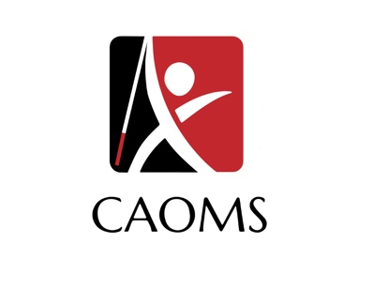
CAOMS STATEWIDE CONFERENCE 2024
“O&M: The Happiest Profession on Earth”
Hyatt Regency Orange County
Friday December 6th 6:00 pm – 8pm
Saturday December 7th 8:00 am – 5 pm

REGISTRANT INFORMATION:

NAME:__________________________________________________
ADDRESS:______________________________________________
CITY:____________________________________________________
NAME OF SCHOOL/AGENCY:_________________________
JOB TITLE:______________________________________________
EMAIL:__________________________________________________
HOME/CELL PHONE:__________________________________
WORK PHONE:_________________________________________

IF YOU WOULD LIKE FINAL PROGRAM IN AN ALTERNATIVE FORMAT PLEASE INDICATE BELOW:

□ BRAILLE
□ LARGE PRINT
□ ELECRONIC FORMAT
CONFERENCE FEES: CHECK THE APPROPRIATE BOX
REGISTRATION INCLUDES Friday night’s event, SATURDAY’S continental breakfast and LUNCH BUFFET

registration: (current and non-members)

□  INDIVIDUAL REGISTRATION ………………………………..$200
□ CURRENT UNIVERSITY STUDENT ……..…………………$100

□ EXTRA SATURDAY LUNCH TICKET……………………….$50
QTY._________

TOTAL DUE: $__________

(Office use only): Paid Zelle_________ Check_________ Other____________

SATURDAY’S LUNCHEON MENU is
BUFFET STYLE including options for Vegetarian Diet, VARIOUS SIDES and desserts
REGISTRATION SUBMISSION AND PAYMENT:
REGISTER BY MAIL AND PAY WITH A CHECK OR MONEY ORDER OR VIA ZELLE USING email:
SCAOMS2018@gmail.com
Or MAKE CHECKS PAYABLE TO “S-CAOMS” AND WRITE “2024 CONFERENCE” AND REGISTRANT’S NAME ON FRONT MEMO LINE.
AFTER COMPLETING THIS FORM PLEASE MAIL/email YOUR PRINTED REGISTRATION FORM AND A CHECK/MONEY ORDER FOR YOUR REGISTRATION TO THE ADDRESS BELOW.

SEND TO:
LALO QUEZADA
1840 S. CURTIS AVE.
ALHAMBRA, CALIFORNIA 91803
Laloquezada@hotmail.com

CAOMS HOTEL INFORMATION
HYATT REGENCY ORANGE COUNTY
11999 HARBOR BLVD.
GARDEN GROVE, CALIFORNIA 92840

HOTEL DISCOUNTED RATE $189.00/NIGHT
Use code/link below:
https://www.hyatt.com/en-US/group-booking/ALICA/G-LC24

(limited time only)

